**Nav-Logo :**

height : 80px

width:100px

**Footer-Logo :**

height : 100px

width:110px

**home-header :**

height : 600px

width:1400px

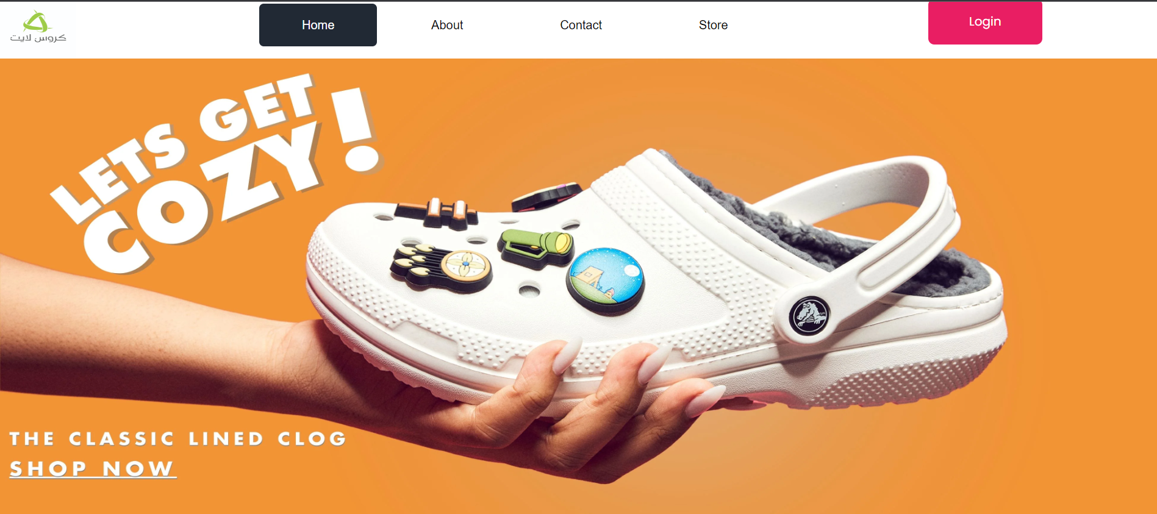

**home-header-mobile :**

width:420px

height:600px



**home-about-section : 3pics**

width:300px

height:300px

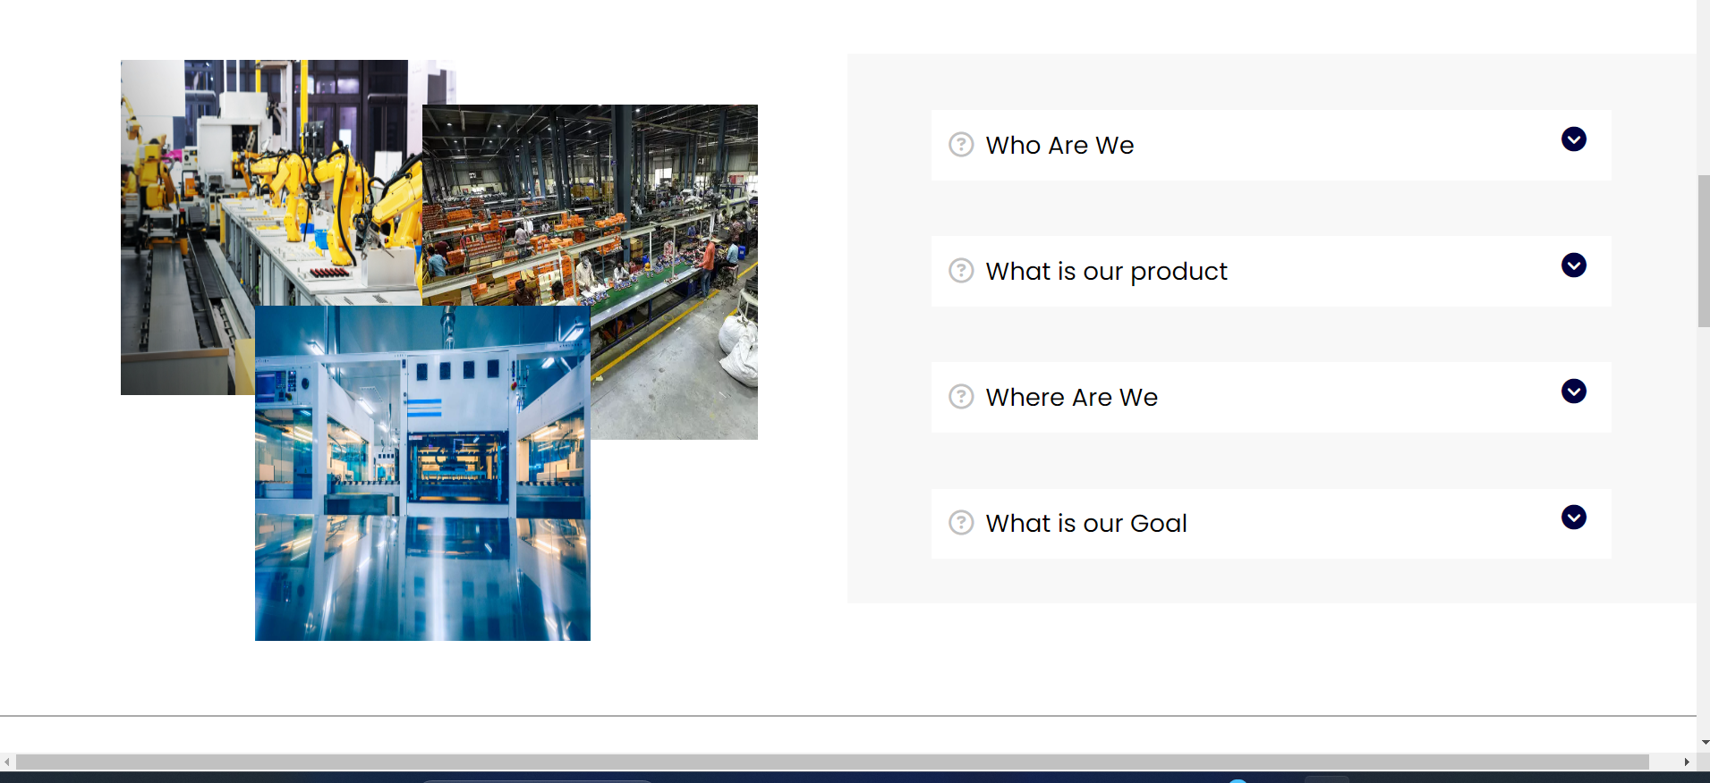

**home-design-section : 3pics (with graphic design like following)**

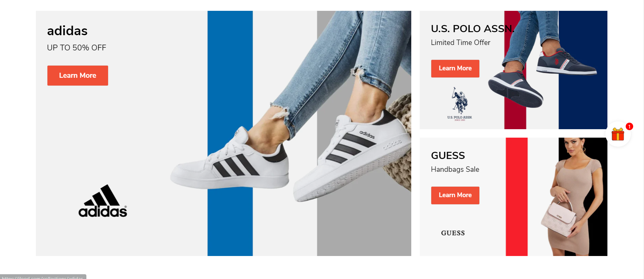

**To replace this one**

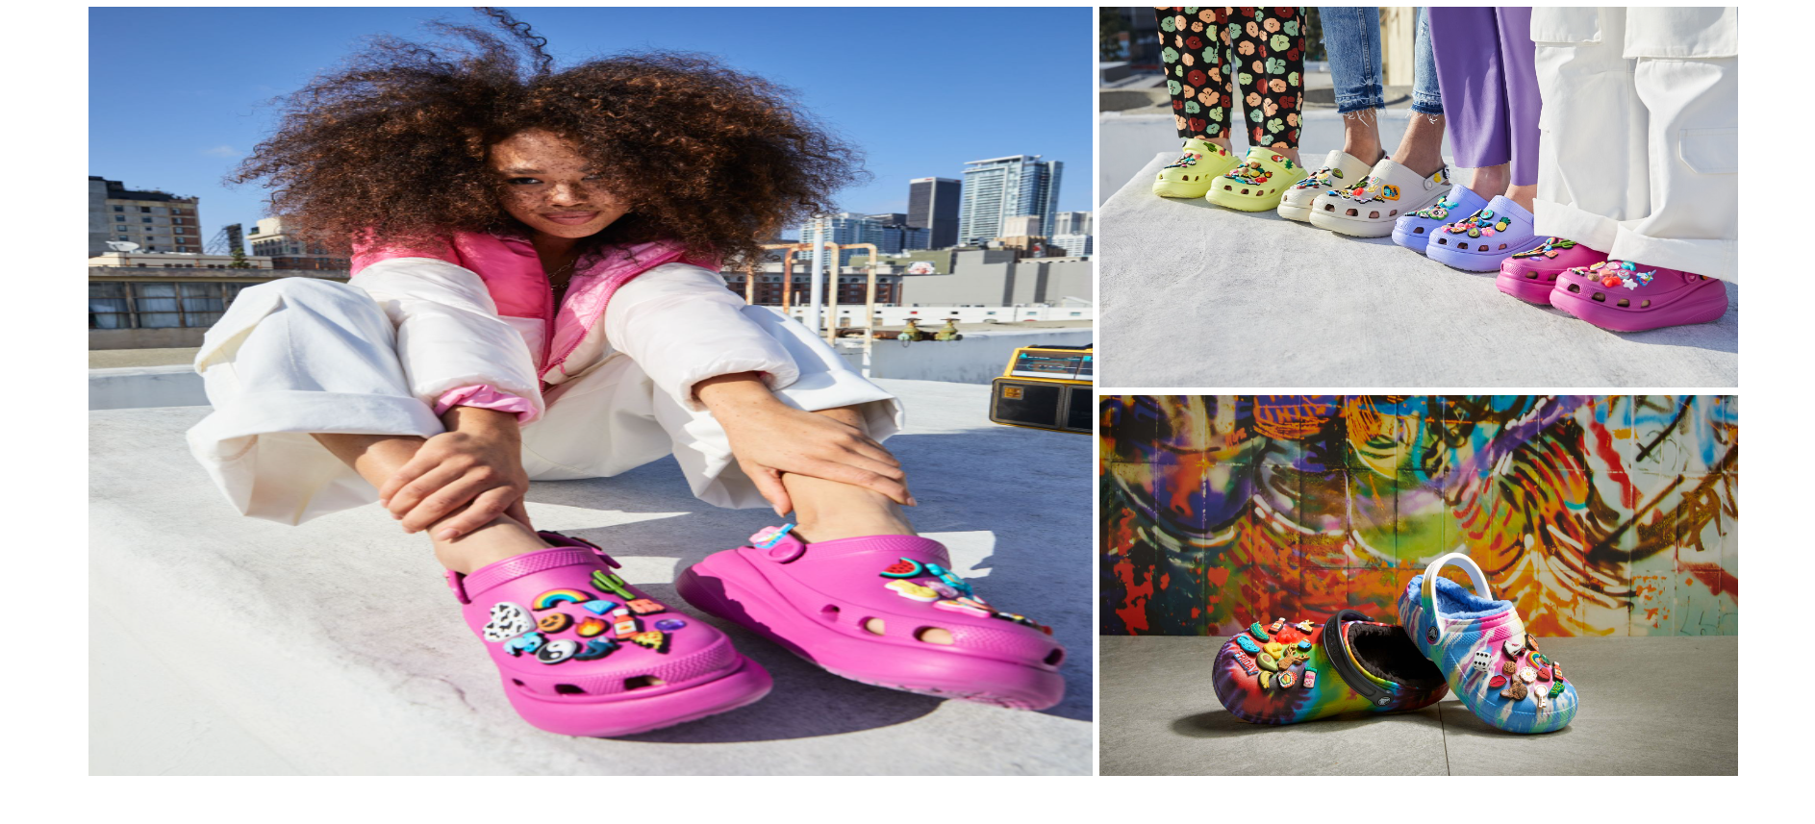

1. width:770px

height:640px

1. width:490px

height:295px

**home-design-section-mobile : 3pics (with graphic design)**

width:670px

height:375px

**Store-card-products : 2 per product**

width:250px

height:250px

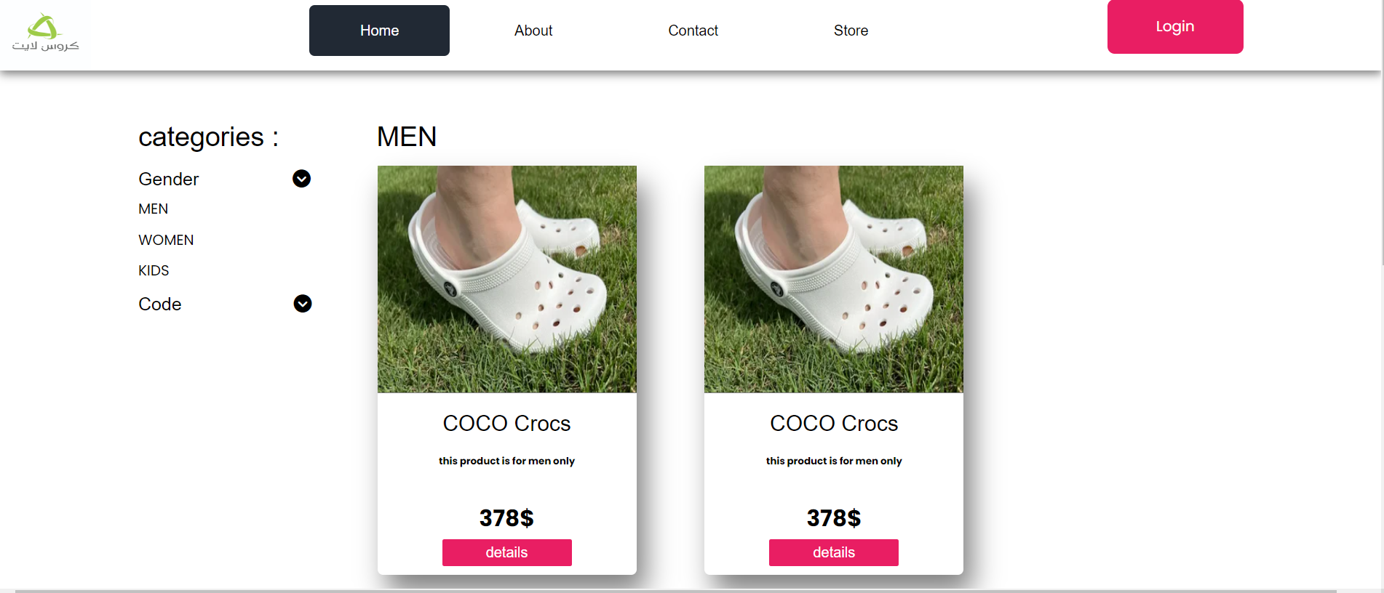

**Store-card-products-mobile : 2 per product**

width:315px

height:250px

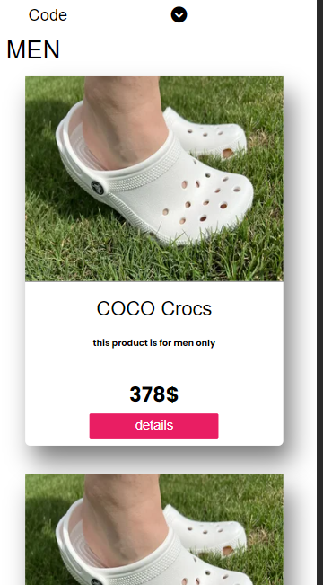

**Store-product-details : 3 minimum per product**

width:490px

height:500px

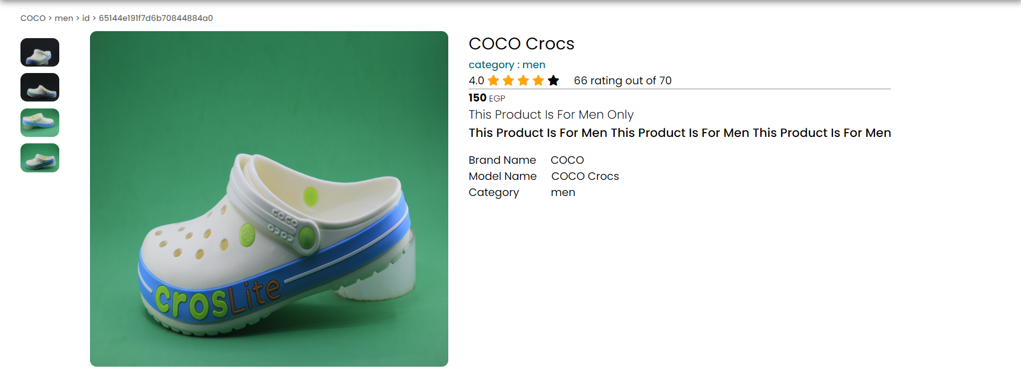

**Store-product-details-mobile : 3 minimum per product**

width:350px,450px

height:500px

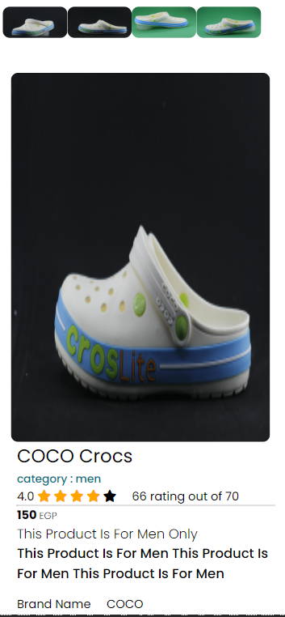

note:

the remaining designs after taking factory and the products details.